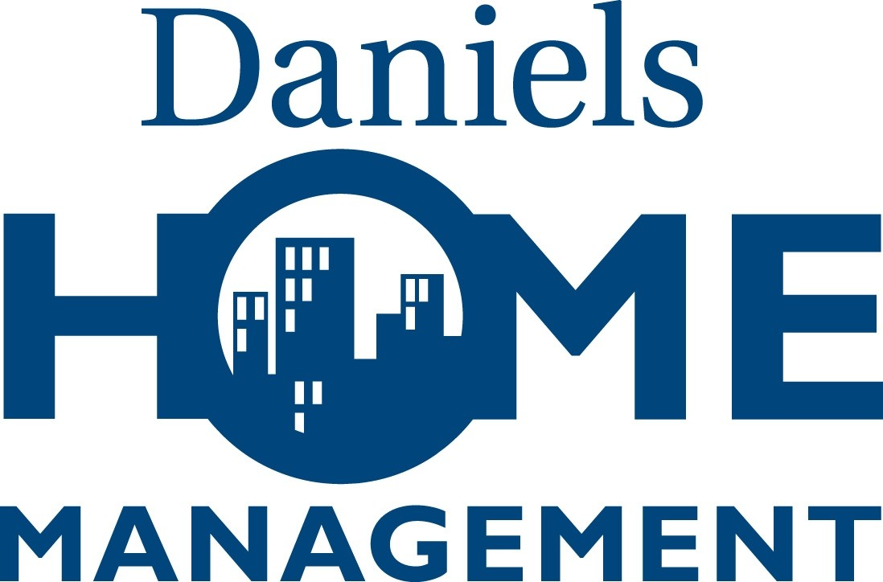
Loading Dock and Service Elevator Reservation Agreement

Reservation Requested By:
Unit #:
Home Phone:
Business / Cell Phone:

This reservation request is for the purposes of (check one):
Incoming Resident (Move-in) | Outgoing Resident (Move-out)
Delivery | Move between unit/locker
Contractor Use

This reservation request requires the use of (check one):
Service Elevator & Loading Dock | Service Elevator only | Loading Dock only

This reservation request is for:
Monday | Tuesday | Wednesday | Thursday | Friday | Saturday

DATE: TIME:

A $250.00 refundable damage deposit, payable only by cheque to Daniels Home Management must accompany this agreement. The deposit is refundable provided that no damage has been caused to the elevator or to any of the common elements during the move. The cost of repairing any damage will be deducted from the deposit.

For Office Use Only
Agreement Form Received | $250 Damage Deposit Received | Verified Resident Information on file | Reservation Added to Calendar
Date: _________ | Date: _________ | Date: _________ | Date: _________

RULES

In requesting the use of the loading dock and/or the service elevator, I understand and agree to the following conditions:

- I will be held liable for all damages by me or by my agents that may occur as a result of the use of the service elevator or loading dock.
- I will only employ professional licensed and bonded movers to conduct my move.
- A reservation, approved by property management, is required for the use of the service elevator or loading dock, and move and deliveries are permitted only in these areas.
- All empty boxes and moving cartons are to be dismantled and removed immediately from the corridors.
- No blockage of the corridors or the elevators is permitted, and it is my responsibility to prevent this.
- Paintbox will not be held liable for any costs pertaining to the delay, if any, in my receiving the service elevator and/or loading dock as booked above.
- I am only entitled to use the service elevator and/or loading dock during the term of my reservation, as defined above.
- It is my responsibility to notify the Resident Service Director or the Concierge when I am ready for the use of the loading dock and/or service elevator for the purpose of damage inspection.
I hereby acknowledge that I have read the agreement as presented above and hereafter, I agree to the Rules and Regulations in force at Paintbox from time to time, and I hereby accept all of the conditions contained herein and in the Rules and Regulations.

Applicant Signature |  | Date

Inspection Report

Area Inspected | Pre-Inspection |  | Post-Inspection
Loading Dock Overhead Door
Loading Area
Service Corridor
Ground Level Doors
Elevator Doors & Frames
Wallpaper & Floor
Unit Door
All Fixtures

Comments:

Pre-Inspection
 | Resident Signature |  | Date
Start Time:
 | Concierge/RSD Signature |  | Date

Post-Inspection
 | Resident Signature |  | Date
End Time:
 | Concierge/RSD Signature |  | Date

Deposit Returned
 | Resident Signature |  | Date
 | Concierge/RSD/Manager Signature |  | Date
Comments:

